**WriteUp**

Created a Docker networking in created EC2 intstance and performed container scheduling over multiple hosts using Docker CLI and connect multiple hosts with Docker containers.

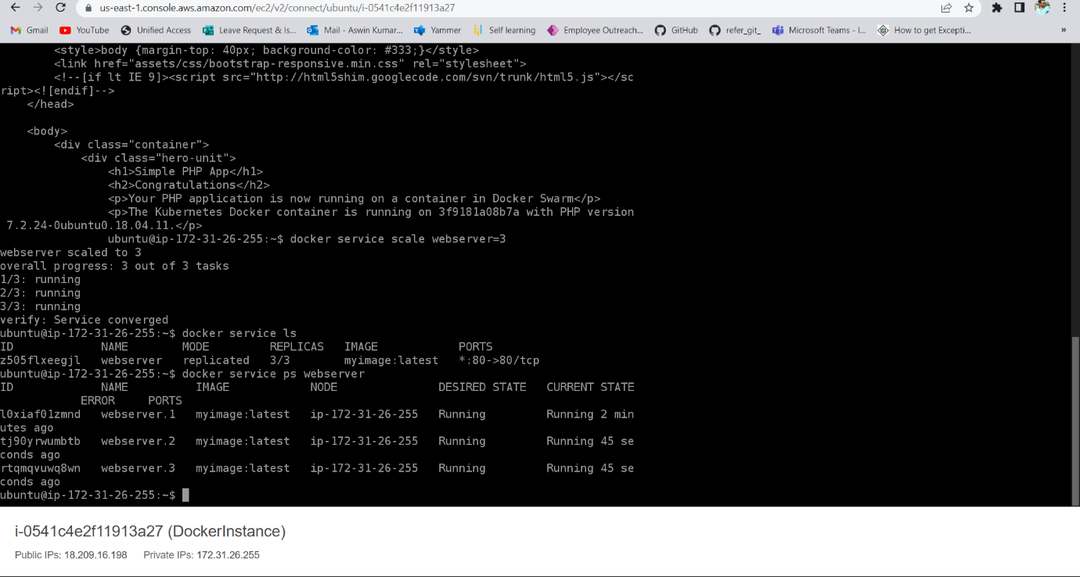

**Step followed in this project:**

* Created DockerInstance in EC2 AWS Cloud with Ubuntu OS.
* Installed docker on Ubuntu OS using commands.
* Clone the git repository to the instance.
* Installed Jenkins and generated admin initial password
* Created jenkin account and installed all necessary plugins.

**Used following:**

● Jenkins: To create a pipeline to deploy Docker Swarm  
● Docker Swarm: To implement container networking  
● GitHub: To store the Angular application